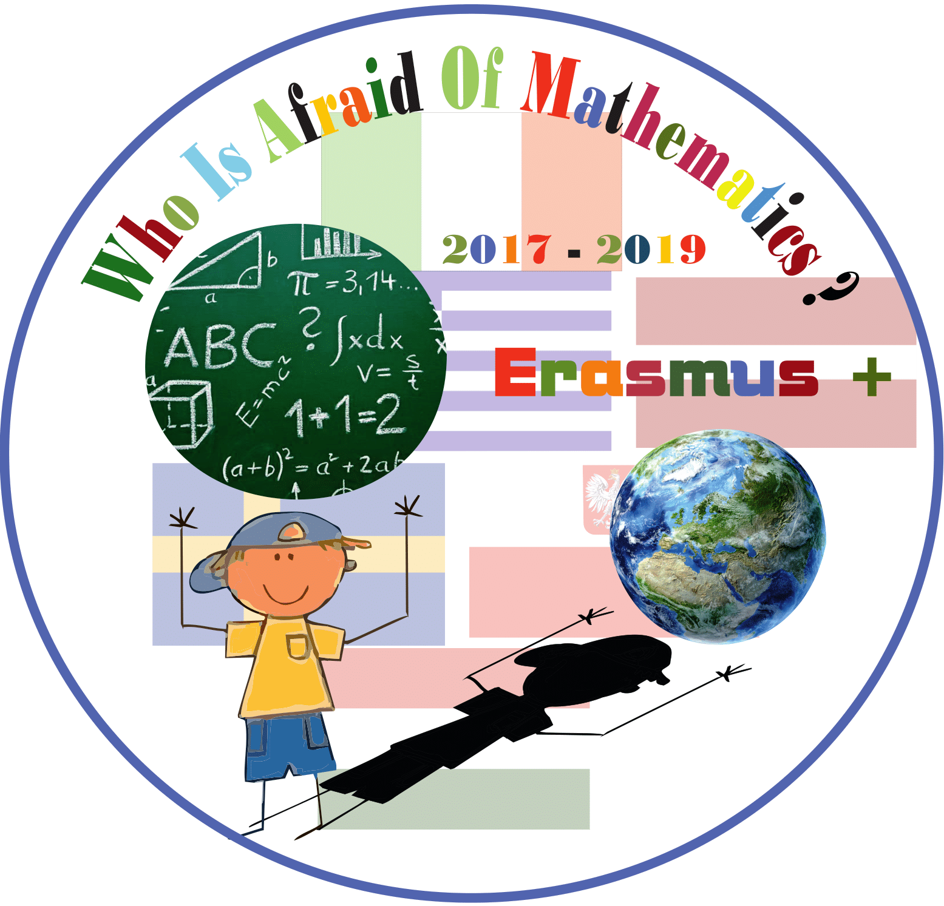

**Category : MATHS IN HISTORY**

**Title of the activity: History through coins**

**Teachers: Buslowska Ewa, Litwinczuk Ewa, Kowalska Mariola**

**Year Group: Grade 5- 6 (10-12 years old)**

**Learning Objectives:**

Pupils

* acquire historical famous Polish and European mathematicians, get to know about their lives and importance of their work
* learn the history of maths, science inventions
* improve memory skills

**Success Criteria:**

Pupils will:

* Realize the similarities and differences European mathematicians
* Compare and contrast modern attitude towards maths.
* Create albums and folders concerning mathematicians in history in the world and Europe

**Introduction:**

We show presentations on the projector and ask students to analyze the life stories and inventions of European historical mathematicians.

We discuss what led to the invention and creation of maths and science achievements and use of them in daily lives

**Differentiation:**

Pupils choose the level of difficulties and the subject of their album. Students are encouraged to help each other during the group work.

Teacher’s assistance is needed during the individual work to ensure that everyone is involved.

Students make their presentations according their abilities to use modern technologies for finding information and using PowerPoint.

**Resources:**

* Images of famous mathematicians in Europe and all over the world, life stories and achievements of ancient and medieval mathematicians.
* Film showing the figures of mathematicians
* Power point Presentation concerning development of maths as science.
* Printed materials (imagies of mathematicians), information about them, paper, glue, other staff needed to make an album
* Pencils, salt clay crayons, scissors

**nnnnnnnnnnn**

**Lesson Description (including context) :**

Lesson “Mathematicians in History” consists of 2 parts: history of mathematicians lives and achievements and practice part – completing the albums about the mathematicians. Pupils are presented materials about historical figures and acquire specific feathers of their inventions and achievements. The lesson provides knowledge about characteristic of the maths figures and pupils analyze the data. The last part is producing albums (every student produces his/her own).

**Main Lesson:**

1. Students are asked to bring information about famous mathematicians in history from home. Together with teacher they analyze the figures. They discuss differences among them, they emphasize the meanings of every figure. The teacher introduced the film about history of maths and science.

2. Students are divided into groups of three to four students. They are provided with visual materials. Groups discuss. .

3. They watch a film about lives and achievements of famous historical mathematicians. Students discuss.

4. Students start preparing their albums.

**Plenary** : At the end of the lesson teacher encourage students to share what they learned in the lesson. Homework for revision of new knowledge – make the graphic mind map with learned figures

