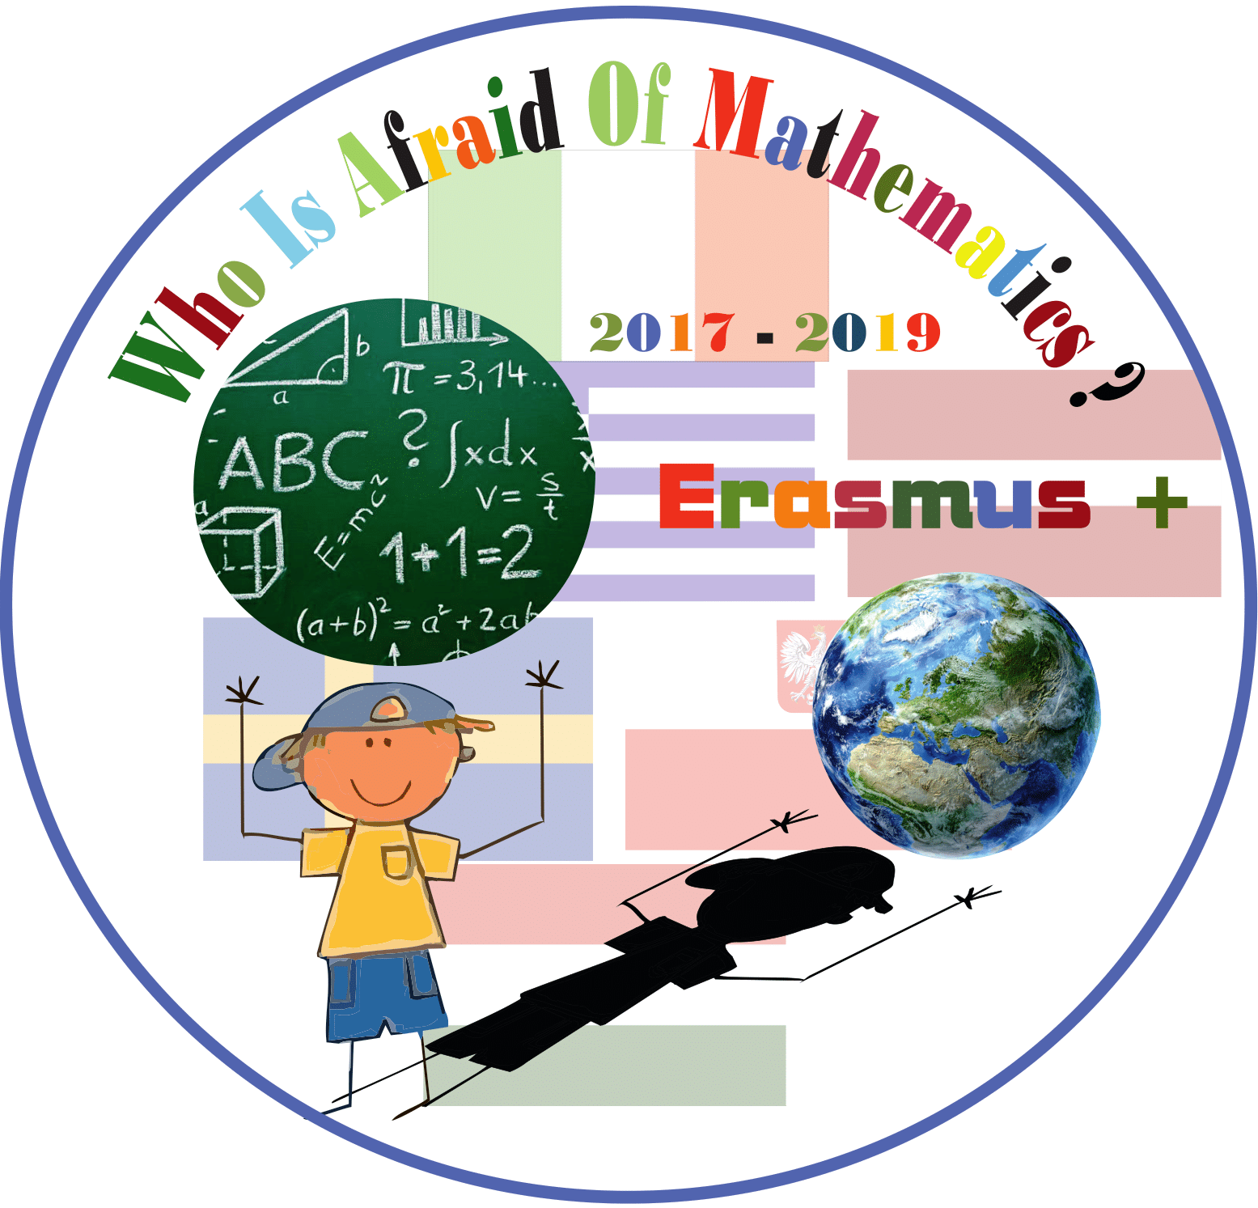

Category : MATHS IN HISTORY

Title of the activity: MILES and STEPS

Year Group: Grade 5 (10 years old)

Teacher: Lucia Guino

Learning Objectives:
- to increase the knowledge about the fact that different parts of human body were the first tools and measuring units in ancient human societies
- to know some measurement units used in ancient Roman society
- to learn the procedure to calculate divisions with decimal numbers as divisor
- to collaborate and to find compromise in order to get a solution

Resources:

- Websites to find information
- Web tools to create mind-maps (www.popplet.com )
- Google docs
- Worksheets
- Calculators
- IWB (Interactive Whiteboard)

Success Criteria:
- to contextualize different calculations in a real situation, as a problem solving
- to collaborate in order to find a procedure to get a solution
- to integrate ICT in a problem solving

Differentiation:
Children work in mixed group but using different abilities.

Lesson Description (including context) :
The activity is task-based on a real situation: children need to know how many steps they do in each mile that they walk twice a week before lunch ( School project “ Un miglio al giorno - One mile a day”)
According to the several sections of the activity, children work with different settlements: plenary, in small groups and individually. The activity is mainly managed in the classroom or in other open spaces in school.

In order to get the aim, children have
- to find information about the meaning of “Mile” and its use in the past
- to find effective strategies and procedures to get a solution
- to estimate length and to measure with proper tools and units
- to convert measures from a system to another

Main Lesson:
Plenary section:
After the introduction and the research of information on the web, children altogether prepare a mind-map on the IWB using popplet website: http://www.popplet.com/app/#/4549399
Each child organize the own mind map in his/her copybook.
Some reflections follow about:
- how ancient Romans measured the lengths in their life context
- the value of the different digits in a measure and on the concept of the estimation and approximation

Group-work section:
Children collaborate in small groups in order to find the procedure to calculate the number of steps they walk in a mile. They choose how to measure, then discuss what type of calculation is needed and at the end they write a short report to be presented to the class.

Plenary:
Each group speaker explains the purposes. All the strategies are written at the moment on a Google doc visible on the IWB and at the end a shared procedure with some steps and strategies is decided. A worksheet by the teacher is prepared based on the results of the discussion. It will help children

Individually:
Children make necessary calculations. One of them requires to apply a new technique which is introduced by the teacher. At the end all the solutions are compared.

Introduction:
The activity is introduced by the teacher talking to the class about the purpose to participate to the National Energy Safe Day. By visiting the relative website, pupils collect pieces of information and about the topic.

Plenary:
Children have enjoyed the activity because it involved group working and movement.
After getting the solution we participated to the national event named “Energy Safe Day- M’illumino di meno” on February 23rd 2018. The event was focused on collecting as many steps as possible from participants’ walking during that week. Children sent an email with the number of their steps to the organizers of the event.
http://www.raiplayradio.it/articoli/2017/11/Millumino-di-Meno-5f36dba8-24f8-4480-9235-080b2db021de.html )

