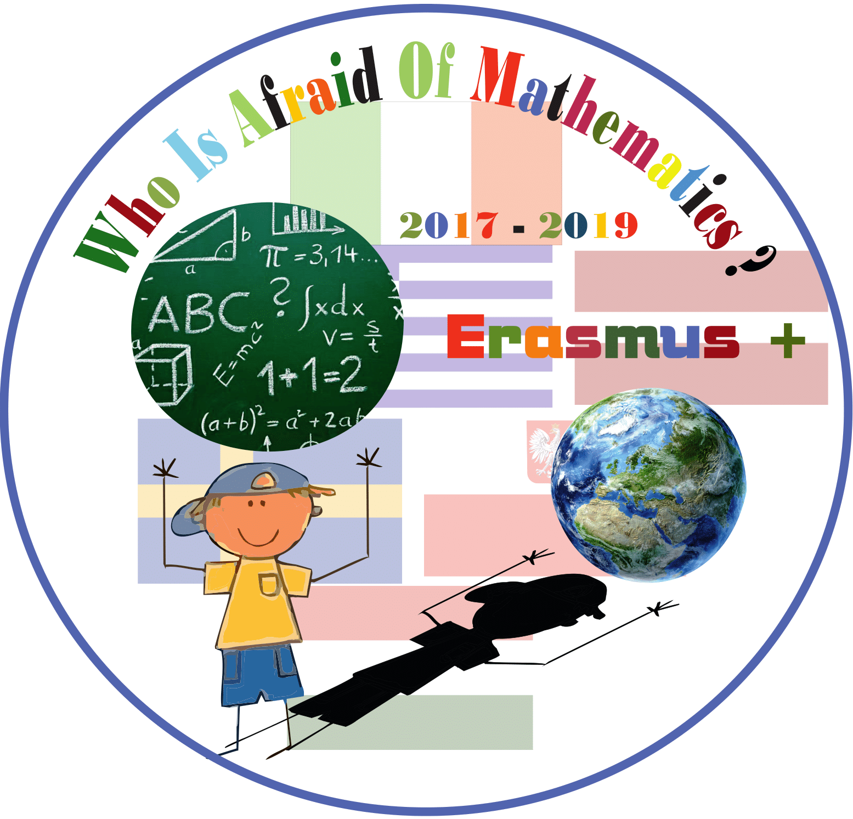

Category : MATHS IN BUSINESS
Title of the activity: Christmas business for charity
Grade: 4 (9 years old)
Learning Objectives:

Pupils to
- get insight of the value of the money
- find ways to make money

Success Criteria:
- Pupils can understand the value of materials they use everyday
- Pupils can calculate the cost of their purchase and the profit they have to have by selling their constructions
- know the money travel through the bank
- payment methods

Resources:
colouring pages
colourful pages
markers
scissors
sticks

Lesson Description (including context):

This lesson took place as a result of an idea of the children wanting to raise money for a non profit institution called "The child's smile''. Following this lesson, the children made hand crafts and sold them to raise money for the charity.
Prior to this activity the children made a research in the market so as to find ways to make a small Christmas business in aim to make money. They bought all the necessary materials, calculated their costing and using their mathematical skills they designed handcrafts and art crafts to sell them in the school guard.
Year Group: Grade 4 (9 years old)

Differentiation:

Paired and group support for children weaker with calculating and organizing this kind of activities.

Introduction:

Discussion about the alternatives pupils have so as to achieve their goal.
The pupils expressed their opinions about all the potential solutions and perspectives so as to decide their activity.
They separated into groups and researched the prices of the materials in the book stores.

Main Lesson:

Ask pupils to design art crafts using shapes (trigon, tetragon, cycles, orthogonal etc
Ask them to think as much different designs of Christmas cards and art crafts they can so as to have a variety of objects to sell.
The pupils are called to put prices on their crafts calculating the cost of the materials so as to have satisfying profit.
They calculate how much money they spent to buy all the materials and how much money they want to achieve and finally put the prices on the staff.
When the activity finishes they go to the bank to deposit the amount of the money to the institution.

Plenary
The students discuss the course, the evolution and the outcome of their action. They think of ways to continue in other ways to raise money and donate them to other organizations in need.

Teachers: Bounatsou Voula & Nopi Foulidou

