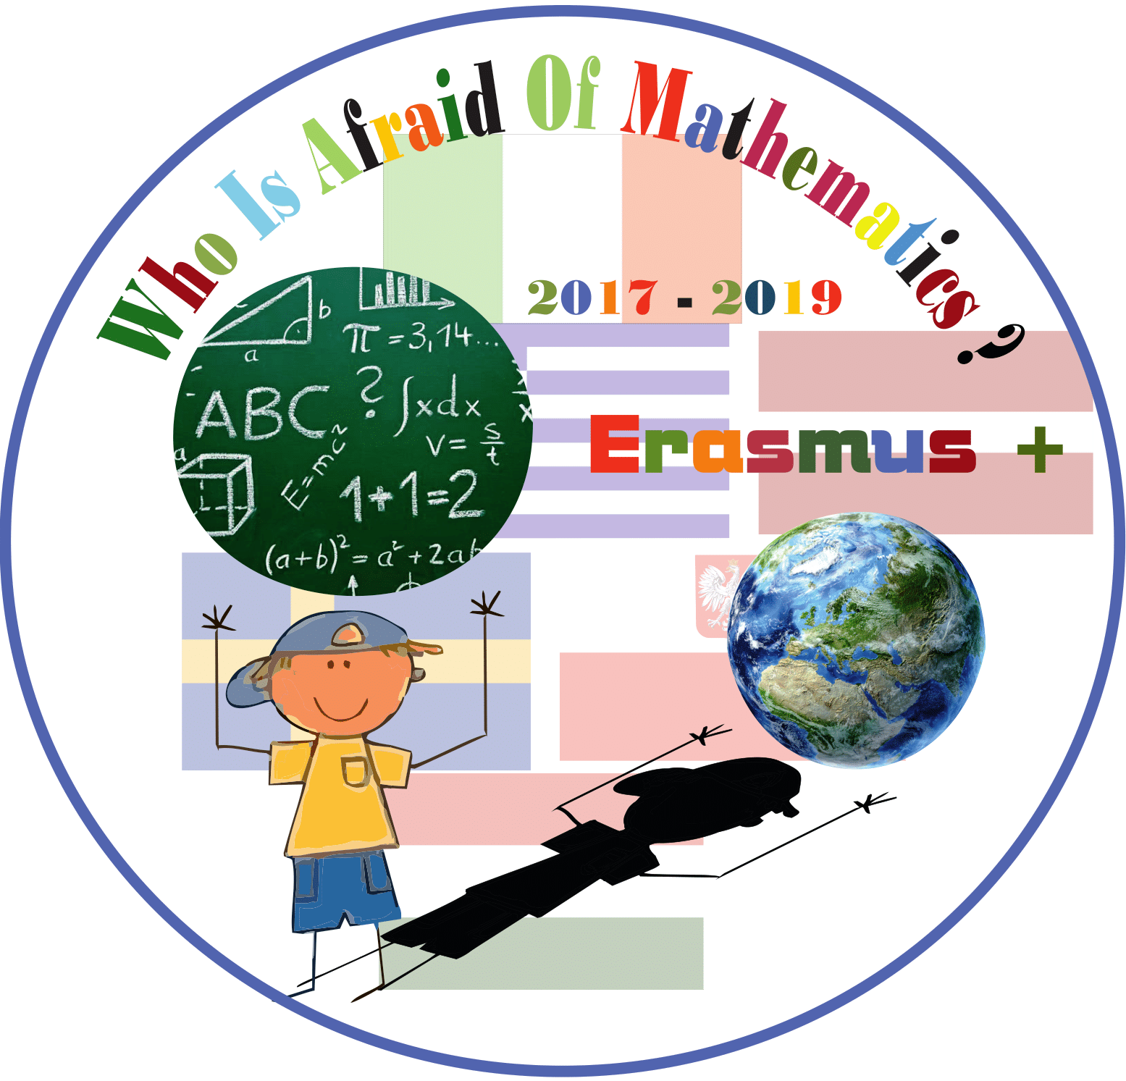

**Category :** **MATHS IN HISTORY**

**Title of the activity: Ancient Greek Mathematicians and Modern Mathematics**

**Year Group: Grade 4 (9 years old) Teacher: Foulidou Nopi**

**Learning Objectives:**

* Pupils learn about the life and work of the ancient Greek Mathematicians
* They observe the importance of the ancient Greek Mathematicians to the evolution of the mathematical thinking and science
* They solve simple arithmetic and geometry problems

**Success Criteria:**

* Pupils will search information and will learn about the life and work of the ancient Greek Mathematicians
* They will create the portraits of the most important ancient Greek Mathematicians and they will give prominence to their contribution to Modern Mathematics
* They will create the timeline of Ancient Times and place the ancient Greek Mathematicians on it
* They will solve problems of additions and subtractions with four -digit numbers
* They will make their own Pythagorean chart and will draw parallel and vertical lines according to the theorems of the ancient Greek Mathematicians

**Resources:**

* Internet
* Laptops, printer, projector
* Worksheets
* Geometric shapes
* Color construction paper
* Color pens
* Scissors, glue
* Camera

**Lesson Description (including context) :**

Through this activity pupils will search and collect information about the life, the work and the contribution of the ancient Greek Mathematicians to Modern Mathematics. During their task, they will make the portraits of the ancient Greek Mathematicians, they will present them to their classmates, they will place them on the timeline in the classroom and finally they will solve simple arithmetic and geometry problems.

**Differentiation:**

The pupils are divided in mixed groups so that the weakest of them can be assisted.

**Introduction:**

The pupils are shown the Pythagorean chart and are asked why this is its name. A discussion follows whether we know any other Greek Mathematicians of the Ancient Times apart from Pythagoras. In this way they decide to deal with this topic in order to get to know the Greek Mathematicians of the Ancient Times and to understand their contribution to Modern Mathematics.

**Main Lesson:**

The pupils are divided into mixed groups of 4.

Each group decides which figure of the ancient Greek Mathematicians they are going to work with, and announces it to the whole class.

Having the use of a laptop each group searches information in the Internet.

The members of the groups collect these information, edit and present them using a projector.

Then, they print a picture and the most important information concerning the life and work of the ancient Greek Mathematician they worked with.

Using color construction paper, they make their portraits to display them in the bulletin board of the class.

They also create the timeline in order to place each Greek Mathematician there, according to his date of birth.

Using the geometrical shapes, the pupils make their own Pythagorean chart and draw parallel and vertical lines following the theorems of the ancient Greek Mathematicians. Finally making good use of the collected information and the timeline they created, they fill in the worksheets , solving problems of additions and subtractions with four -digit numbers, putting numbers in order, and dealing with geometry.

**Plenary :**

The pupils realize that the ancient Greek Mathematicians and their work underlie the scientific thinking of the modern Mathematicians, too.

**Teachers : Foulidou Nopi**

